

**AUTOMATION OF STREET LIGHT SYSTEM**

**Persistent Inspiration Award winners**

**Under**

**Ministry of Steel**

**At**

**Smart India Hackathon 2017 Grand Finale**

**Team Name-Smart Jharkhand**

**Rohan Kumar**

**Akash Verma**

**Rahul Ranjan**

**Aman Choudhary**

**Vikas Kumar Pandey**

**Sumit Prasad Sahu**

**Ashutosh Gupta**

**Aim:** To automate the street light by using open weather API and to reduce the electrical energy by alternating the street lights.

**Summary:**

This project of AUTOMATED STREET LIGHTS is a cost effective, practical, ecofriendly and the safest way to save energy. It clearly tackles the two problems that world is facing today, saving of energy and also disposal of incandescent lamps, very efficiently. According to statistical data we can save more that 40 % of electrical energy that is now consumed by the highways. Initial cost and maintenance can be the drawbacks of this project. With the advances in technology and good resource planning the cost of the project can be cut down and also with the use of good equipment the maintenance can also be reduced in terms of periodic checks. The LEDs have long life, emit cool light, donor have any toxic material and can be used for fast switching. For these reasons our project presents far more advantages which can over shadow the present limitations. Keeping in view the long term benefits and the initial cost would never be a problem as the investment return time is very less. Budget of connecting 80 streets lights.

The project has scope in various other applications like for providing lighting in industries, campuses and parking lots of huge shopping malls. This can also be used for surveillance in corporate campuses and industries.

**Introduction:**

Saving power is very important, instead of using the power in unnecessary times it should be switched off. In any city “STREET LIGHT” is one of the major power consuming factors. Most of the time we see street lights are ON even after sunrise thus wasting lot of energy.

Automatic street light system can overcome these problems. All the manual working can be taken over by the automatic street light system. It has longitudinal and latitudinal values which observes the current weather of the place and monitors the sunlight and sunset of the specified place. This also decreases the cost and time complexity of the manual street light system. Fewer technician can take care of the system and this will also decrease the risk factor involved with their life. By staying at one place they can switch ON and OFF the light without manually involving with the lights and hence decreasing the intensity of human error.

Automation of street lights systems may help to reduce some of the power consumption and hence will help us to fairly consume the energy without wastage.

Turning off of alternate lights in the midnight can also save more than a half of energy because at midnight the light requirement is low because there are less number of vehicles running on the road and they too have their own headlights that lead to have enough light intensity for visibility clearance.

**Objectives:**

* Turning On/Off street lights without manual operation
* Synchronization with sunset and sunrise
* Integrating weather information by using Open Weather API
* Reduce power consumption by turning off alternate lights at midnight.
* Easy to manufactured.

**Status:**

Currently the technology used in the street light is LDR which works on the principal of light intensity. The sensors test the light intensity and switch ON the lights when the light intensity is low according to the sensor. But many times it is seen that the intensity of sunlight is appropriate for visibility but due to LDR sensors the lights gets switched ON. Hence, wasting the energy.

Another problem with LDR is that if dust and shadow resist on the sensor it senses it as low light intensity and turn ON the light. And if the light is focused and reflected on the sensor it doesn’t turn ON the light in spite the light intensity is low in the surrounding. For this the sensor need to be cleaned in very short intervals because the street light stands on roadways and the get dirty easily by the vehicles exhausts. So, the LDR increases the maintenance work and again it would be required easily.

Automatic street light system can overcome these problems. All the manual working can be taken over by the automatic street light system. It has longitudinal and latitudinal values which observes the current weather of the place and monitors the sunlight and sunset of the specified place. This also decreases the cost and time complexity of the manual street light system. Fewer technician can take care of the system and this will also decrease the risk factor involved with their life. By staying at one place they can switch ON and OFF the light without manually involving with the lights and hence decreasing the intensity of human error.

On a foggy day they can turn ON the lights and remain it on till it is needed. They don’t need to be present at the site to monitor the sunlight intensity. It will be monitored by the monitoring system for the lights.

For solution of the LDR problem is taken over by putting the sunrise and sunset into the server and the lights get switched ON and OFF accordingly. It saves lot of energy when there is no need of the lights to be kept ON. And it doesn’t need heavy maintenance as LDR it only requires regular updating of the sunrise and sunset timing. Which can be approached by replacing few codes and saves a lot of time as well as cost.

**Novelty:**

* We are replacing LDR system with internet of things
* we are using weather forecasting to gain data.
* To cope with the wastage of electricity, we can alternately switch off the street lamps in

**Work Plan:**

Saving power is very important, instead of using the power in unnecessary times it should be switched off. In any city “STREET LIGHT” is one of the major power consuming factors. Most of the time we see street lights are ON even after sunrise thus wasting lot of energy.

So we have made an automatic street light system which can control over the lights by weather forecasting and sunset/sunrise timing.

It has longitudinal and latitudinal values which observes the current weather of the place and monitors the sunlight and sunset of the specified place. This also decreases the cost and time complexity of the manual street light system. Fewer technician can take care of the system and this will also decrease the risk factor involved with their life. By staying at one place they can switch ON and OFF the light without manually involving with the lights and hence decreasing the intensity of human error.

On a foggy day they can turn ON the lights and remain it on till it is needed. They don’t need to be present at the site to monitor the sunlight intensity. It will be monitored by the monitoring system for the lights.

The technician can keep record of the functioning of the lights. Problem can be rectified without going over the problem site and the technician can carry the necessary parts which are to be replaced for proper functioning of the lights.

Because of the lights controls connected with Open Weather API the server keeps updating the weather of the place and the sunrise and sunset time which helps in proper and efficient working of the light without wastage of the energy.

Energy efficiency is one of the most important factor in our country because mostly the electricity produced is by using non-renewable source of energy which is not easily replenished. And the consumption of energy is very high and the supply is very low which leads to blackouts.

Automation of street lights systems may help to reduce some of the power consumption and hence will help us to fairly consume the energy without wastage.

**Architecture schematic**

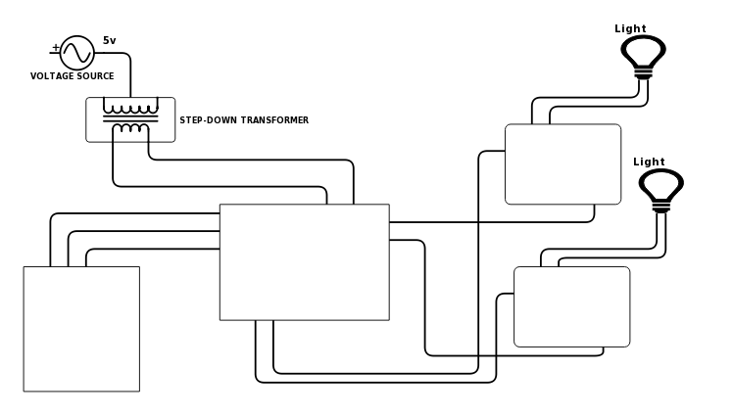

RELAY 2

RELAY 1

BLUETOOTH

MICROCONTROLLER

ANDROID

Tx

GND

VCC

VCC

GND

Tx

NO C

GND

IN 2

IN 1

GND

NO C

DISPLAY

ROUTER

INTERNET

OPEN WEATHER API

**Time line and responsibility of participating team:**

|  |  |  |  |  |  |  |  |  |
| --- | --- | --- | --- | --- | --- | --- | --- | --- |
|  | **Particulars** | | **Time (months)** | | | | | |
| # | **Tasks** | **Team Member’s Name** | **1st Month** | **2nd Month** | **3rd Month** | **4th Month** | **5th Month** | **6th Month** |
| 1 | Microcontroller programming | Rohan Kumar |  |  |  |  |  |  |
| 2 | Weather data | Akash verma |  |  |  |  |  |  |
| 3 | Android app | Rahul Ranjan |  |  |  |  |  |  |
| 4 | Php and layout | Vikas Kr.Pandey |  |  |  |  |  |  |
| 5 | Electrical part | Ashutosh Gupta |  |  |  |  |  |  |
| 6 | connection | Aman Choudhary |  |  |  |  |  |  |
| 7 | Back end | Sumit Prasad Sahu |  |  |  |  |  |  |

**Comprehensive budget:**

Budget requirements (total as well as individual institutions/laboratory along with monthly break-up covering manpower, travel, contingencies, overheads, others (if any) and equipment for the 6-month project duration).

|  |  |  |  |  |  |  |  |
| --- | --- | --- | --- | --- | --- | --- | --- |
| **Head of Expenditure** | **1st Month** | **2nd Month** | **3rd Month** | **4th Month** | **5th Month** | **6th Month** | **Total** |
|  | **Recurring** | | | | | | |
| Travel | 50400 | 50400 | 50400 | 50400 | 50400 | 50400 | 302400 |
| Contingencies | 4000 | 4000 | 4000 | 4000 | 4000 | 4000 | 24000 |
| Other research expenditure (e.g. Outsourcing) | - | - | - | - | - | - | - |
|  | **Non-recurring** | | | | | | |
| Equipment and accessories | 10000 | - | - | - | - | - | 10000 |
| Licensing cost (for using proprietary technology, if any) |  |  |  |  |  |  |  |
| **Total** | 64400.00 | 54400 | 54400 | 54400 | 54400.00 | 54400.00 | 336400.00 |

*\*\*\* In addition to this, team members will be paid a stipend by the concerned ministry/ department during the period of the project.*

**References:**